THIS IS THE STORY OF THE BEGINNING OF DARTMOUTH FIRE DISTRICT 2 (COPIED FROM THE 50TH ANNIVERSARY BOOK)
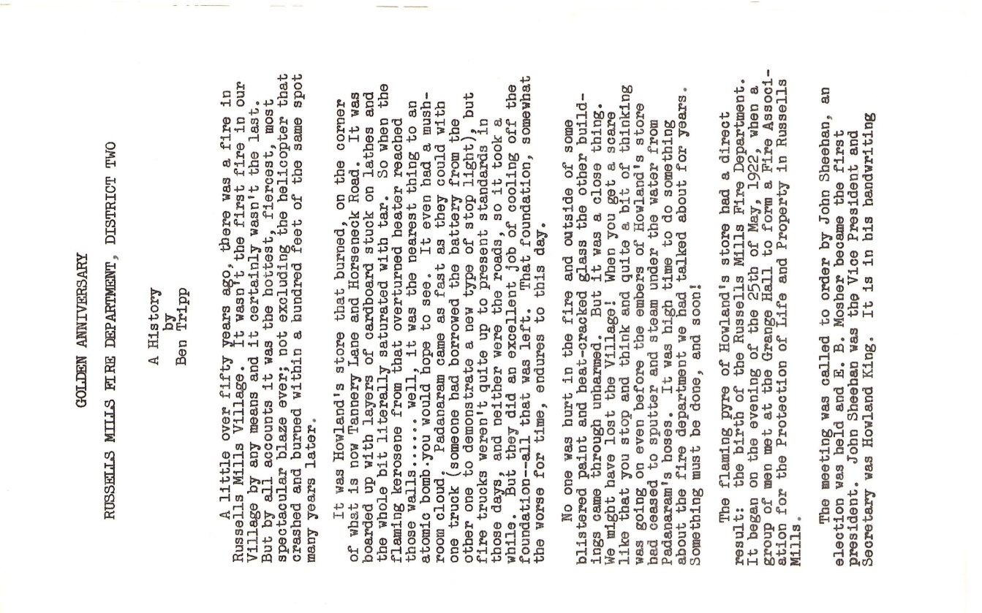
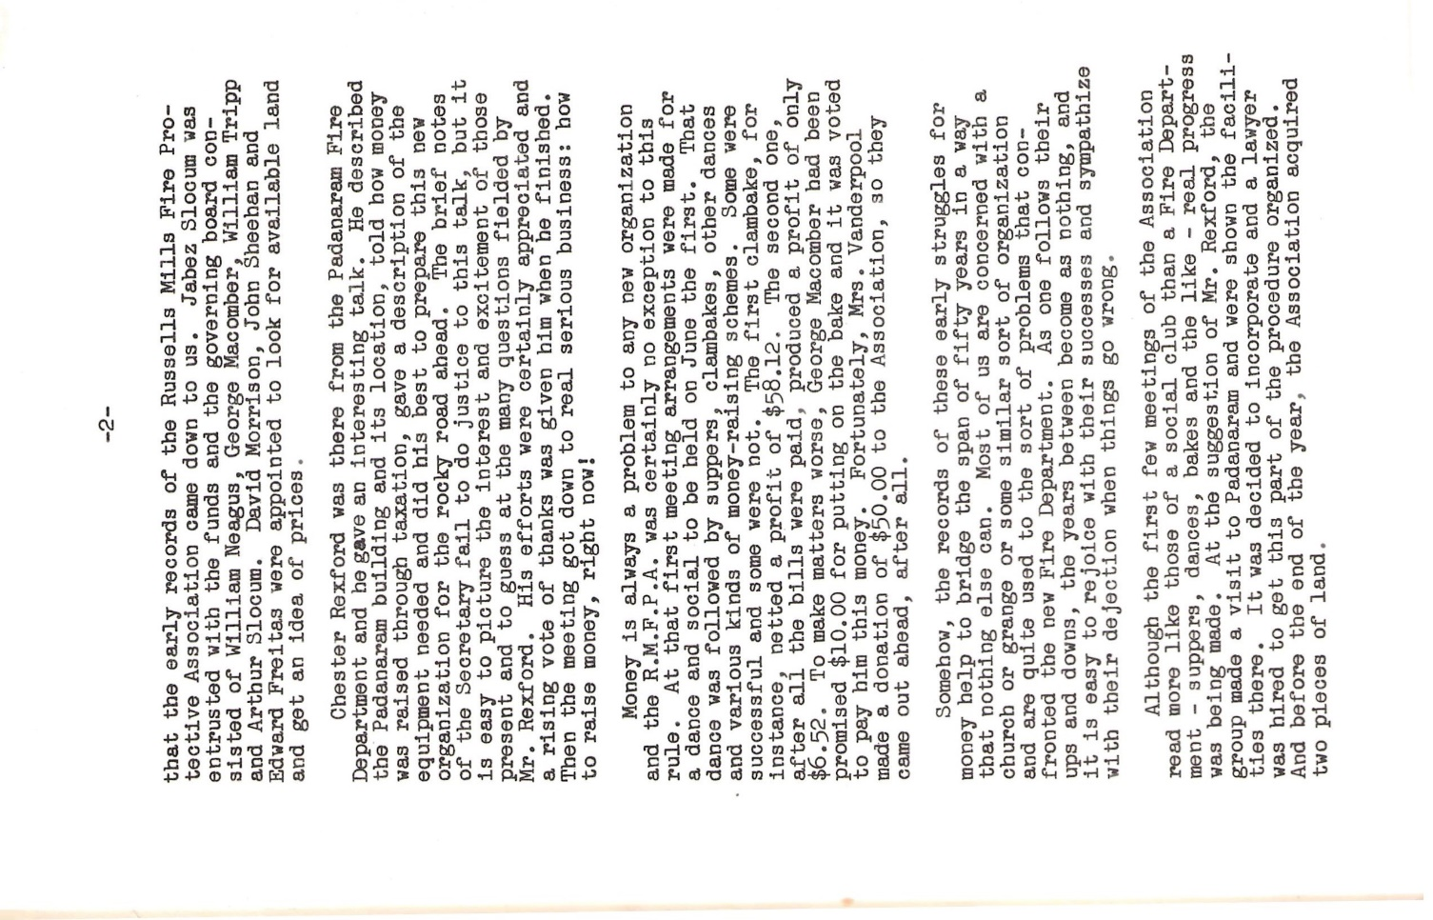
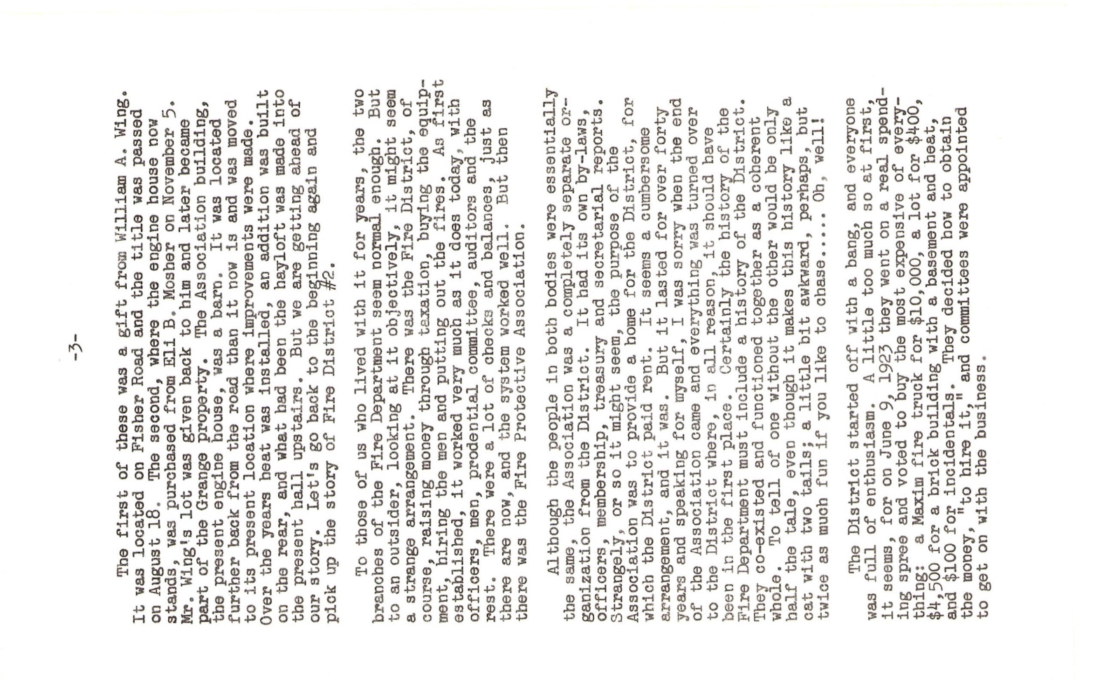
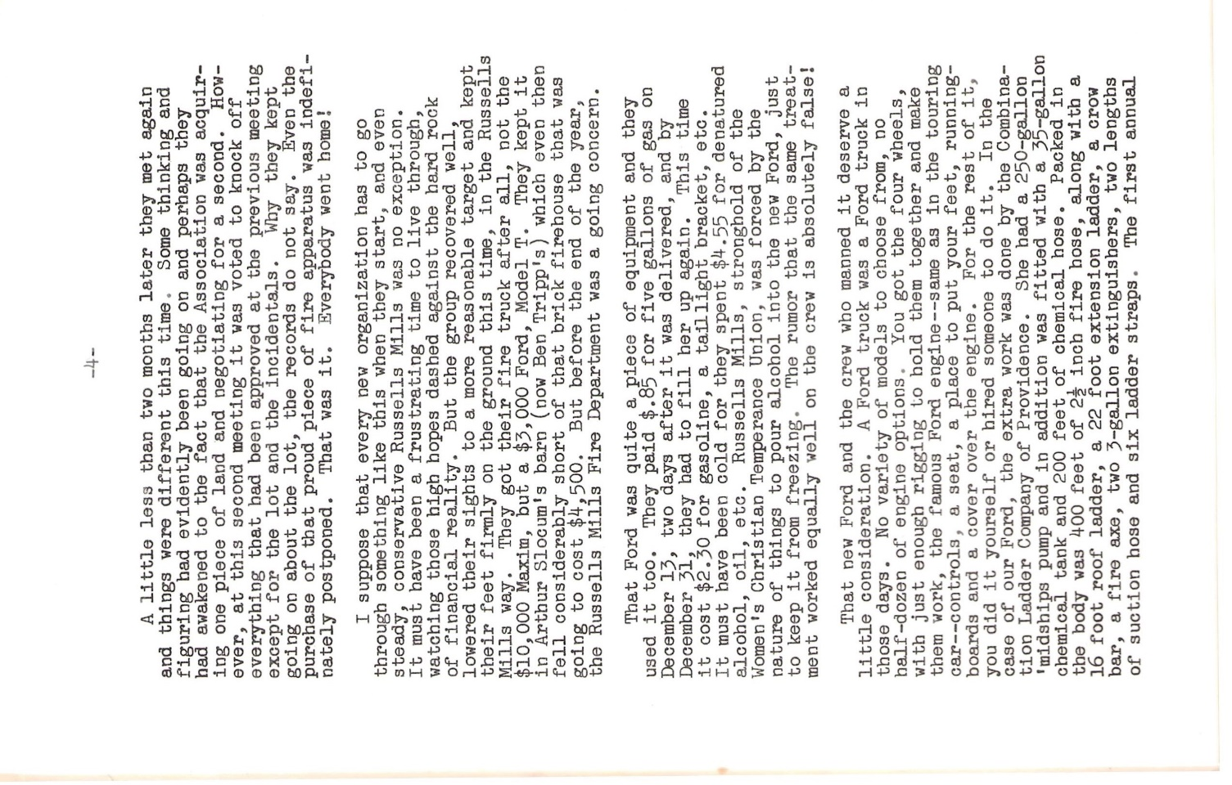
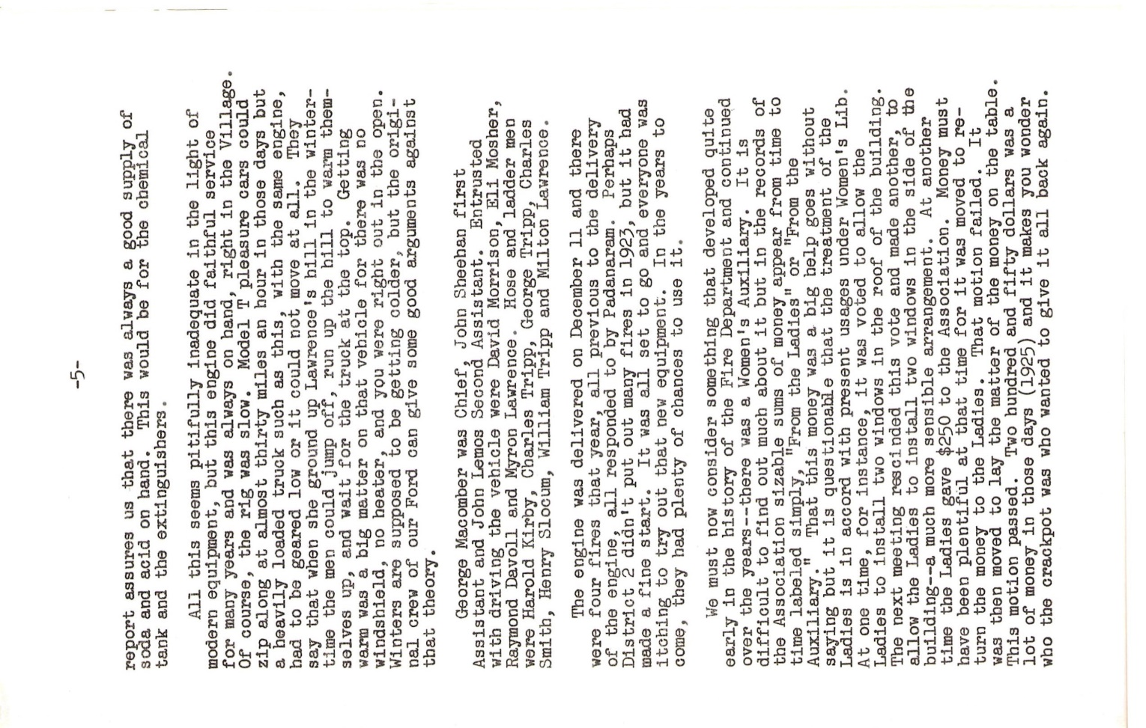
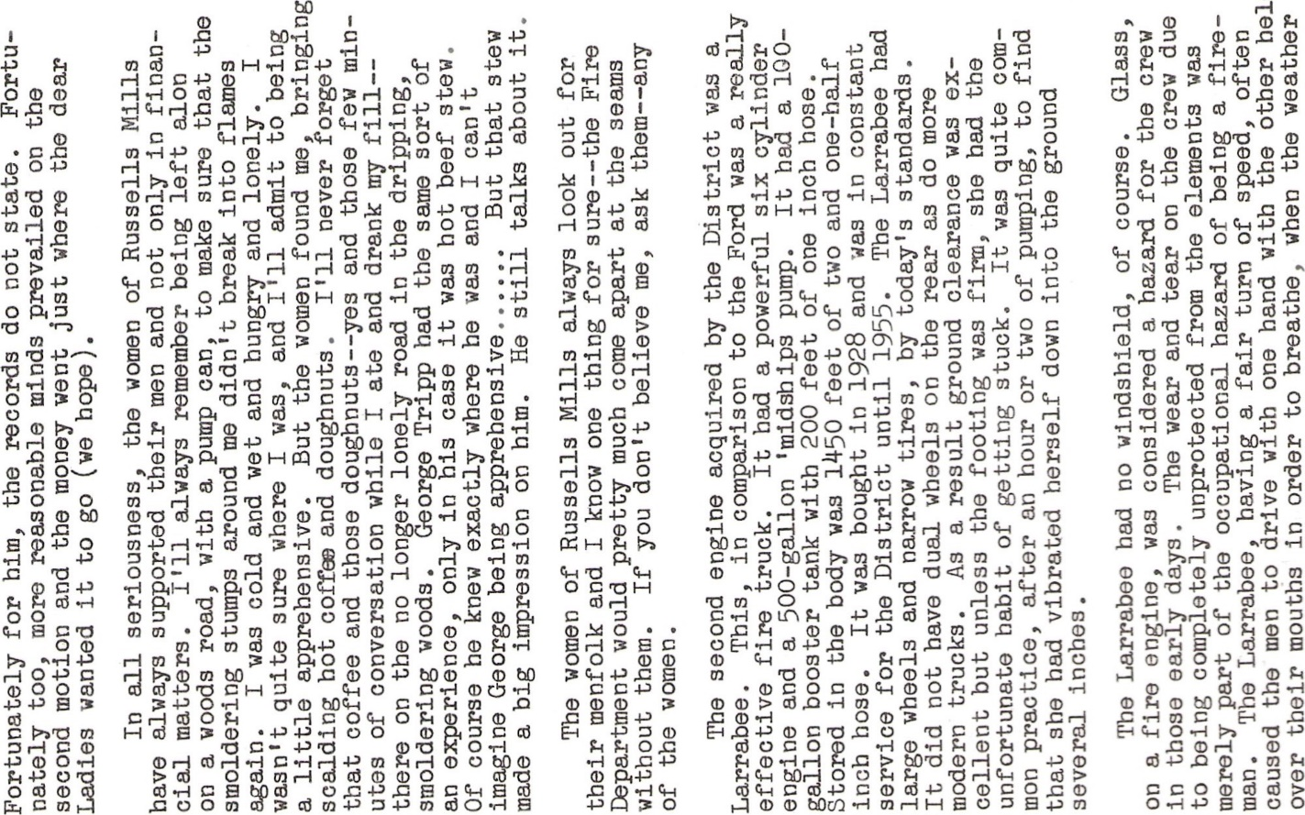
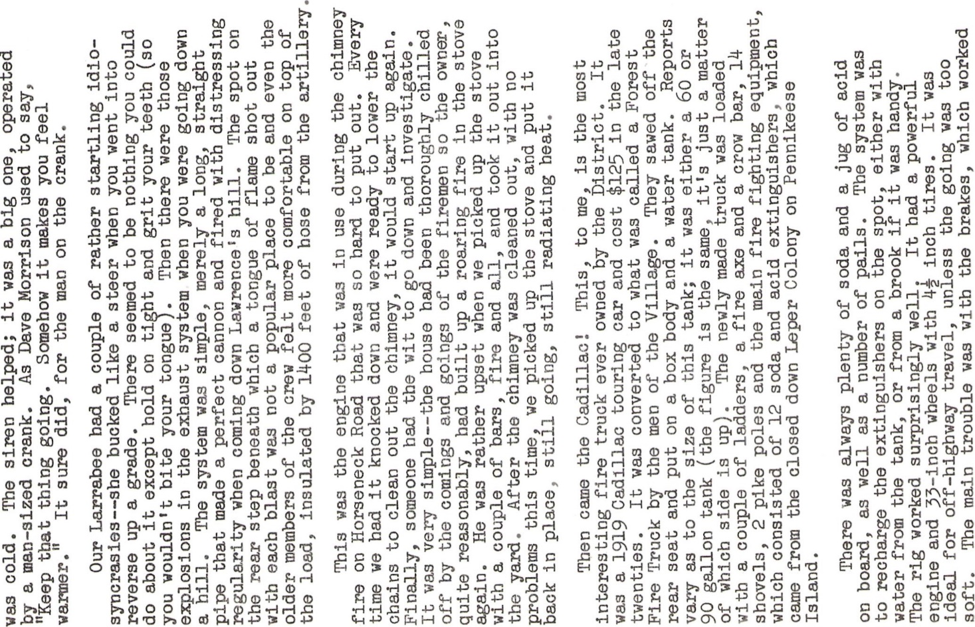
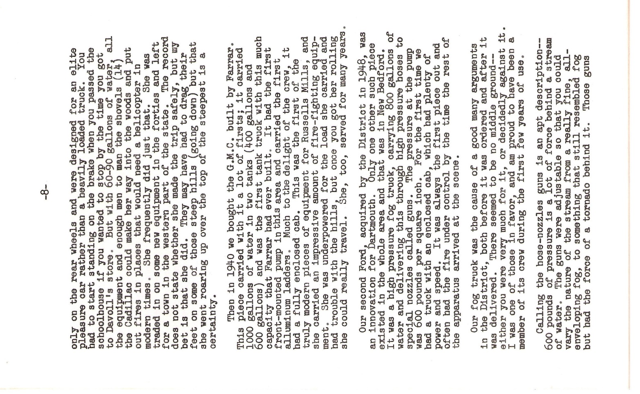
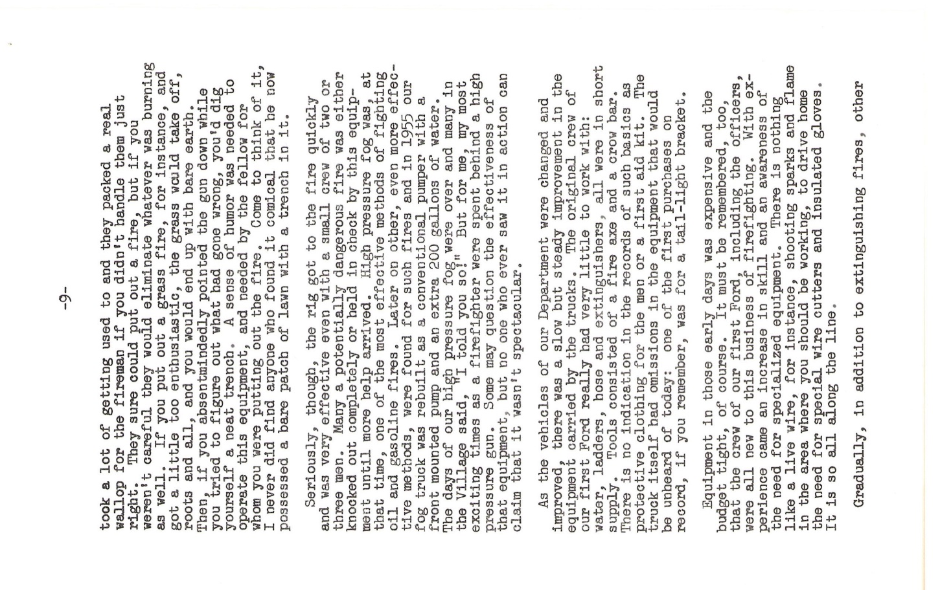
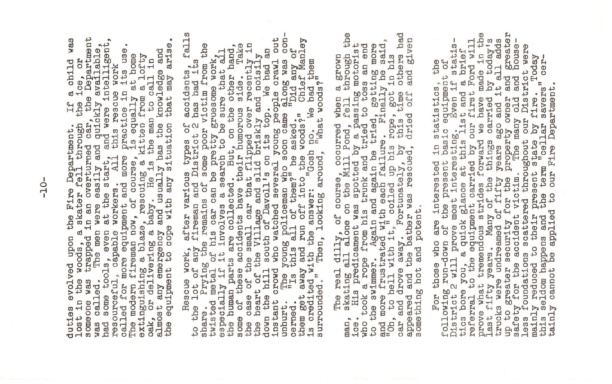
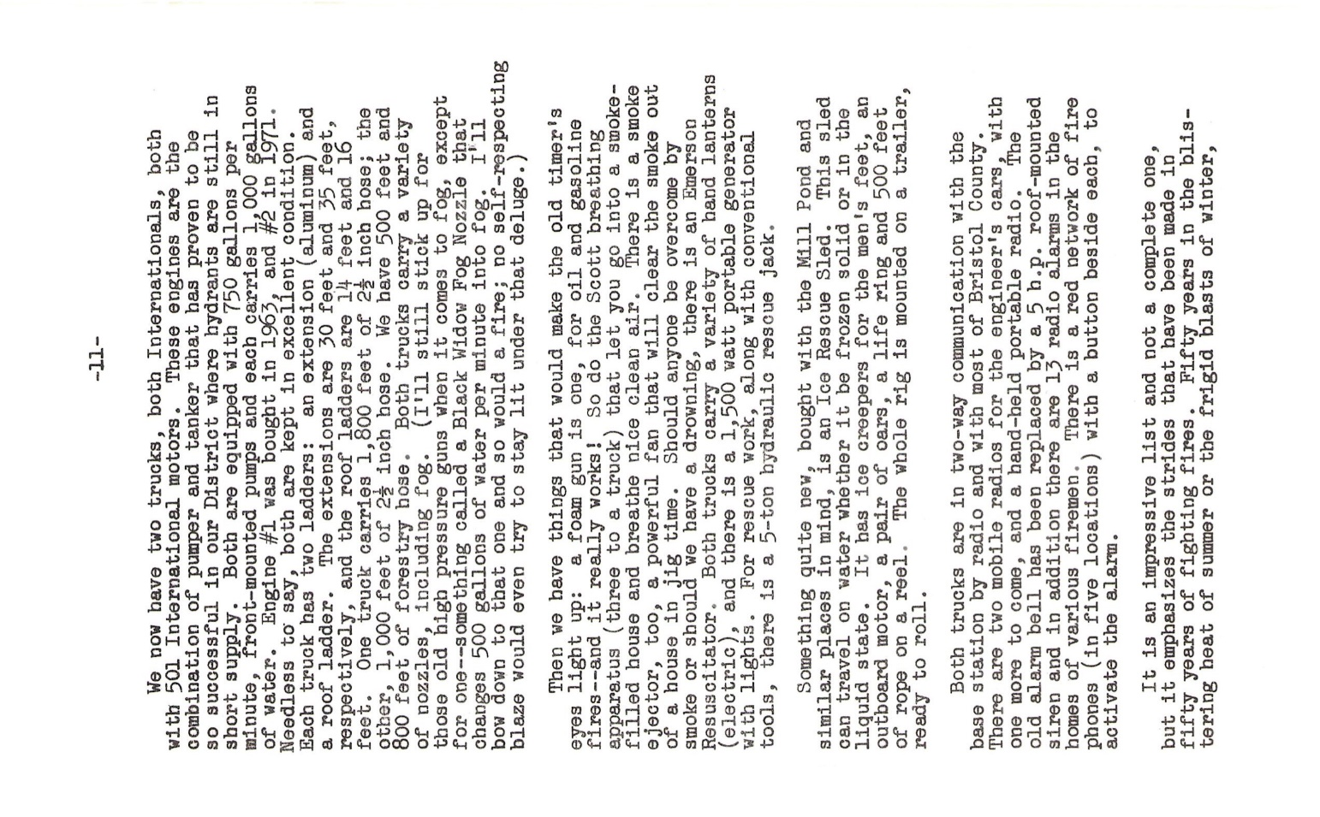
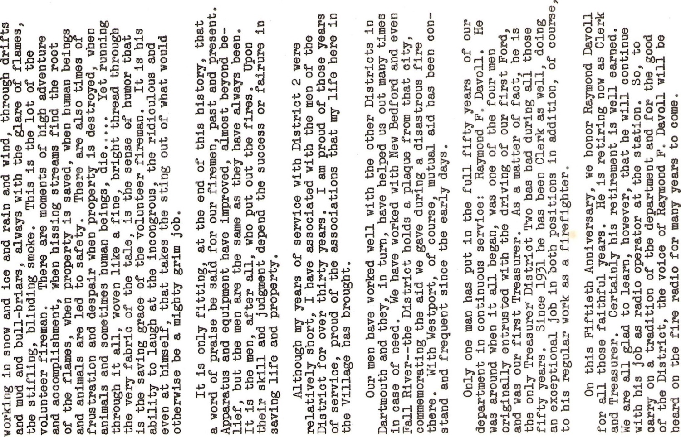
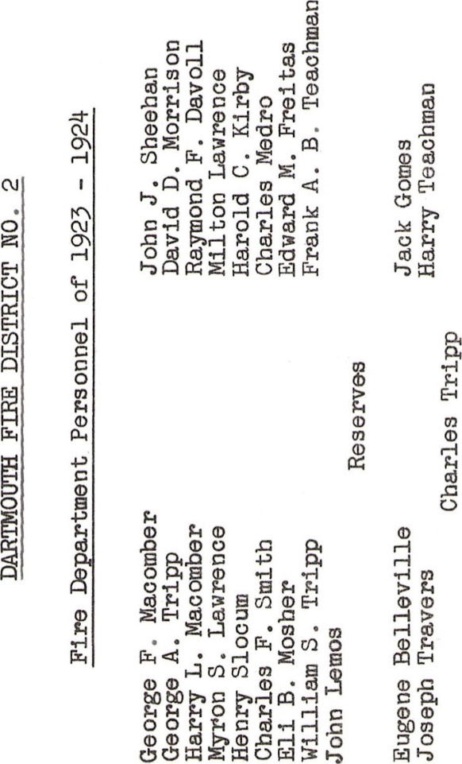

FIRE CHIEFS WHO HAVE SERVED THE DISTRICT
George F Macomber - 1923-1928/1931-1937 – 11 years
David D Morrison – 1929-1930 – 1 year
John J Sheehan – 1929-1944/1947-1955 – 23 years
Wilfred Morrison – 1944-1947 – 3 years
Kenneth Morrison – 1955-1966 – 11 years
Jesse Folger Jr – 1966-1970 – 4 years
Allen Manley – 1970-1979/1992-2002 – 19 years
Raymond Davoll Jr – 1980-1991 – 11 years
Timothy J Andre – 2002-2021 – 19 years
Gregory Edgcomb (acting chief) – 2021-2022 – 1 year
Wayne Thomas (acting chief) – Nov-Dec 2022 – 1 month
Erick Turcotte – Dec 2022 – present

